Abstract:

This project aims to manage and analyze energy consumption data to improve efficiency and sustainability. The process involves several key steps: identifying an energy consumption dataset, preprocessing and cleaning the data, extracting relevant features, developing statistical models to uncover trends and anomalies, creating visualizations for insights, and automating the entire process with a script. By implementing this approach, we can gain valuable insights into energy usage patterns and make informed decisions to optimize energy consumption.

Module Overview:

1. Data Source (Data Collection):

• Objective: Identify an available dataset containing energy consumption measurements.

• Description: This module involves sourcing and collecting a dataset that contains energy consumption data. It may include data from various sources like sensors, utility bills, or smart meters.

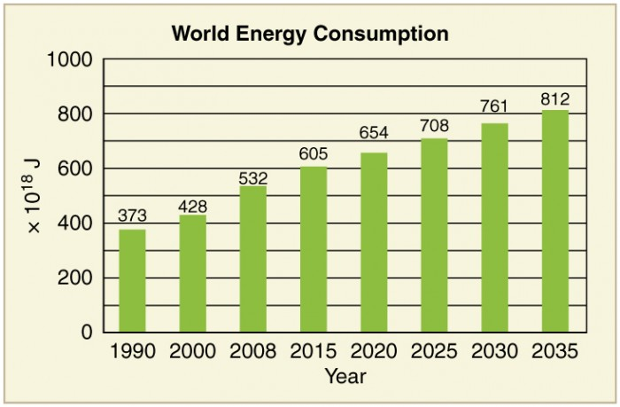

2. Data Preprocessing:

• Objective: Clean, transform, and prepare the dataset for analysis.

• Description: In this module, the collected data will be cleaned to remove outliers and errors. Missing values will be handled, and the data may be transformed for consistency.

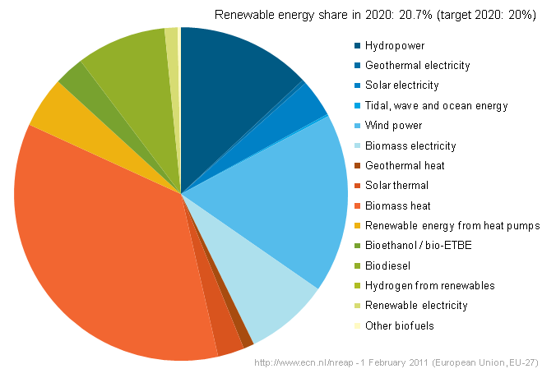

3. Feature Extraction:

• Objective: Extract relevant features and metrics from the energy consumption data.

• Description: This module focuses on identifying and extracting meaningful features and metrics from the preprocessed data. These features could include daily consumption patterns, seasonal variations, peak usage times, etc.

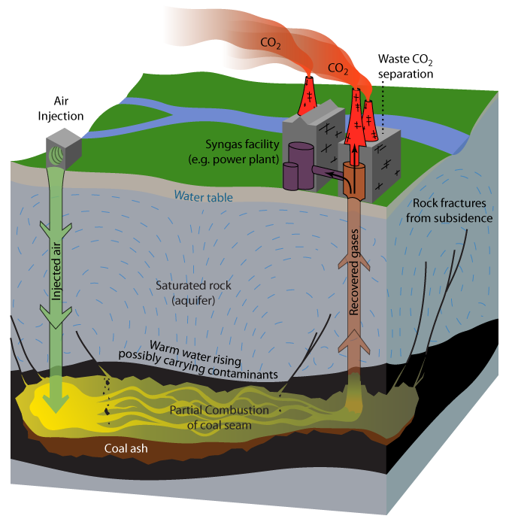

4. Model Development:

• Objective: Utilize statistical analysis to uncover trends, patterns, and anomalies in the data.

• Description: Statistical models and analysis techniques will be applied to the dataset to identify trends, patterns, and anomalies. This step may involve time series analysis, clustering, or regression models.

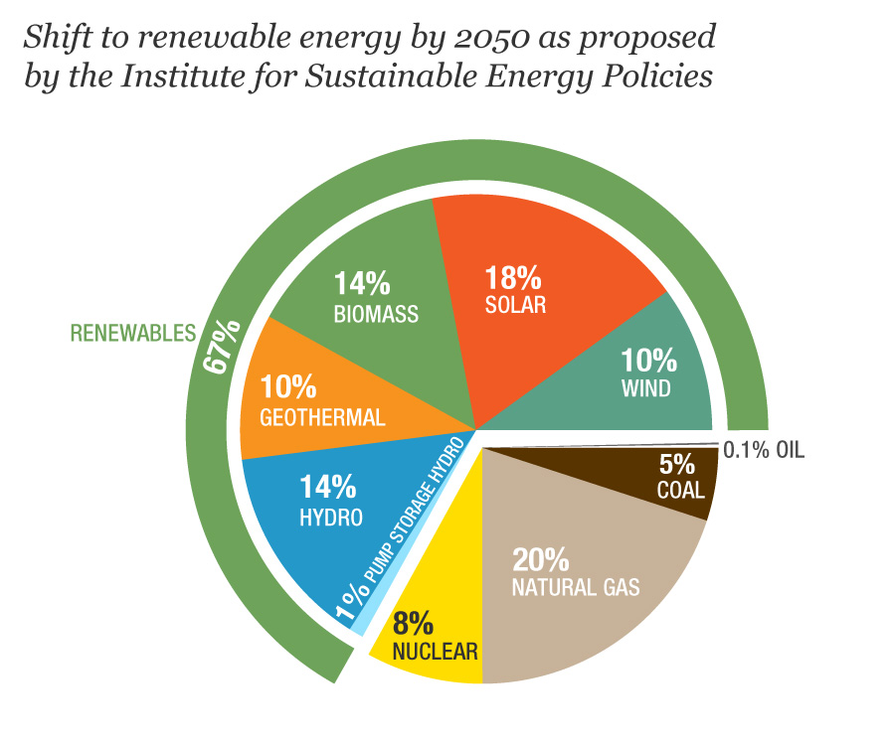

5. Visualization:

• Objective: Develop visualizations (graphs, charts) to present the energy consumption trends and insights.

• Description: Visualizations will be created to make the insights from the data more accessible and understandable. Graphs and charts can help stakeholders visualize consumption trends and patterns.

6. Automation:

• Objective: Build a script that automates data collection, analysis, and visualization processes.

• Description: An automated script will be developed to streamline the entire process, from data collection to visualization. This script will ensure that the energy consumption management process can be repeated efficiently.

By following these modules, this project aims to provide a comprehensive solution for managing energy consumption, enabling better decision-making and resource optimization in various sectors.

